**Assignment 4**

NAME – Aadit Agarwal

Roll No – 2018IMT 001

Course – Machine Learning (ITIT 4103)

**Aim**

1. Use a scatter plot to visualize the data, since it has only two properties to plot (profit and population).

2. Consider a simple linear model with two parameters and one input variable and mean square error cost function to implement the gradient descent algorithm to find the intercepts. Assume a suitable terminating condition.

3. Plot the model alongside the scatterplot to show the fit model.

4. Perform steps 1,2,3 in batch mode for varying values of alpha, learning rate and plot the results.

5. For each of the experiments performed above in steps 1,2,3,4 with varying learning rates visualize the cost function as a contour plot as well as plot the values of parameters to visualize the stepwise traversion of the parameters on this contour plot.

* Objective 1

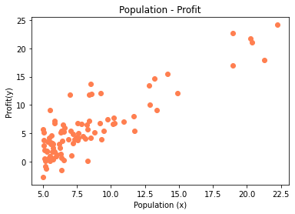

* Objective 2
* Mean square error Equation

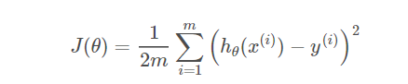

* Linear regression model Equation

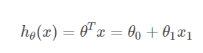

* Gradient Descent equation 
* Objective 3

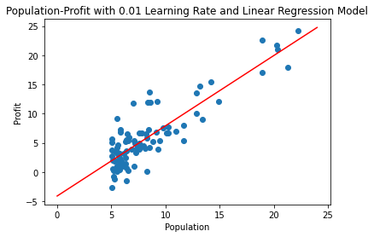

* Objective 4

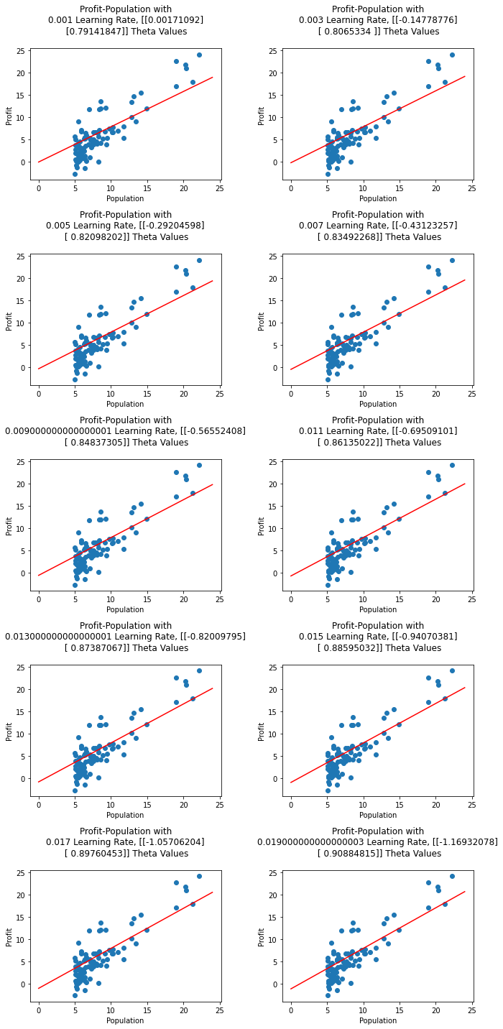

* Objective 5

